**Problem 11.3**

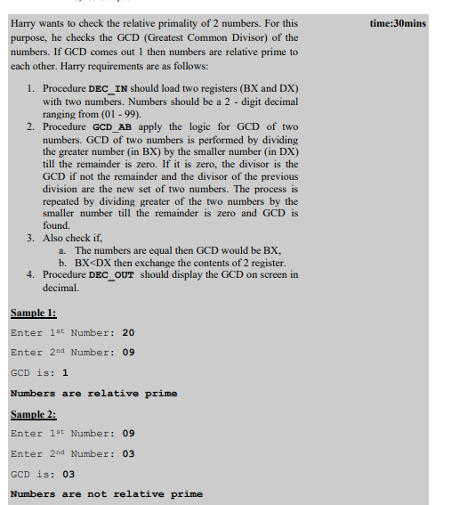

**Solution :**

.data

NUM1 DW 000AH

NUM2 DW 0004H

GCD DW ?

.code

START: MOV AX,DATA ;Load the Data to AX.

MOV DS,AX ;Move the Data AX to DS.

MOV AX,NUM1 ;Move the first number to AX.

MOV BX,NUM2 ;Move the second number to BX.

UP: CMP AX,BX ;Compare the two numbers.

JE EXIT ;If equal, go to EXIT label.

JB EXCG ;If first number is below second, go to EXCG label.

UP1: MOV DX,0H ;Initialize the DX.

DIV BX ;Divide the first number by second number.

CMP DX,0 ;Compare remainder is zero or not.

JE EXIT ;If zero, jump to EXIT label.

MOV AX,DX ;If non-zero, move remainder to AX.

JMP UP ;Jump to UP label.

EXCG:XCHG AX,BX ;Exchange the remainder and quotient.

JMP UP1 ;Jump to UP1.

EXIT:MOV GCD,BX ;Store the result in GCD.

MOV AH,4CH

INT 21H

**Problem # 1**

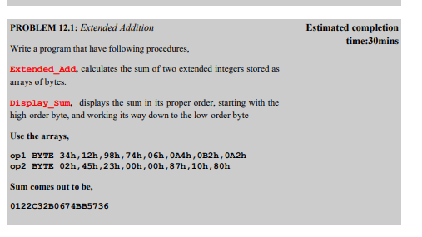

**Solution**

include irvine32.inc

.data

msg1 db " Enter the First number: ", 0

msg2 db " Enter the Second number: ", 0

num1 dd ?

num2 dd ?

.code

main PROC

mov al,05h

mov dl,0fh

call gotoxy

mov edx, offset msg1

call writestring

call readdec

mov num1,eax

mov edx, offset msg2

call writestring

call readdec

mov num2,eax

add eax,num1

call writedec

call crlf

EXIT

main endp

end main